VS Code help
===========\
# Last amedned: 19th Dec,2025
# GitHub folder: install_ai_tools/quick_flowise_ollama/venv

1. Ubuntu: How to change to VScode’s python virtual environment:

This is the recommended method for selecting an environment for your current workspace.
  - Open the Command Palette: Press Ctrl+Shift+P (Windows/Linux) or Cmd+Shift+P (macOS).
  - Search for the command: Type "Python: Select Interpreter" and select it from the list of commands.
2. Ubuntu: Which is my current working python Virtual environment:

1. Check the Status Bar
The easiest way to see the active interpreter is to look at the bottom-right corner of the VS Code window. The name and version of the currently selected Python interpreter will be displayed there.
- If no interpreter is selected, it might say something like "Python" or "Select Interpreter".
- Clicking on this area is a shortcut to change the interpreter.

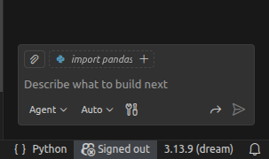Figure 1: Bottom right of VS code mentions 'dream' as the active python interpreter

3. WSL: Visual Studio Code selecting python environment in WSL

Broadly steps are:
1. Install WSL2 in Windows
2. Install Visual Studio Code in Windows
3. Install almost all WSL: Extensions in Vscode. No need to install python extensions first, if we are not working in a python virtual environment within Windows.
5. Quit VScode in Windows.
4. Open WSL, install therein either anaconda3 and then create a conda virtual environment or install a python virtual environment.
5. Switch to this python environment. Type command code . (note that ‘dot’ is a part of command). This will start Vscode and on bottom left you will have WSL: Ubuntu22.04

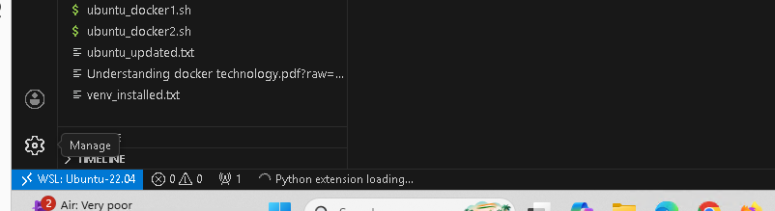Figure 2: Visual Studio Code started in WSL. Note the blue label WSL: Ubuntu
6. Next install necessary python extensions in Vscode for WSL.
7. Once done, you can then select a python interpreter, as usual, with ctrl+shift+P. You will see all your python virtual environments that exist in WSL.
Google AI generated reply is as below:
To select a Python interpreter in WSL within VS Code, you must be running VS Code in a WSL remote window. The main reasons for this issue are typically running VS Code in Windows mode instead of WSL mode, or problems with the Python extension.

Primary Solution: Ensure VS Code is running in WSL Mode. You cannot select a Linux Python executable (which does not have a .exe extension) from a Windows instance of VS Code.
    - Install the Remote - WSL extension in VS Code if you haven't already. You can find it in the Extensions marketplace (Ctrl+Shift+X).
    - Open your project from within WSL:
      - Open your WSL terminal (e.g., Ubuntu) in Windows.
      - Navigate to your project directory in the Linux file system.
      - Type code . and press Enter. This command launches VS Code and automatically connects to the WSL environment.
    - Verify the connection: The lower-left corner of the VS Code status bar should show "WSL: [YourDistroName]".
    - Select the interpreter: Once in WSL mode, open the Command Palette (Ctrl+Shift+P) and type "Python: Select Interpreter". You should now see the available Linux Python interpreters and virtual environments.
#########

